**Computer programing**

**Project Report**



**SUBMITED TO**

Sir Sheryar Khan

**SUBMITED BY**

Muhammad Azam Anwar

Roll number: 21-CP-76

DEPARTMENT OF **COMPUTER ENGINEERING**

UET TAXILA

Date: 06-08-2022

**Market administration and billing management**

When a user will open this there will be three options for the user. 1st open is for the administrator. 2nd will be for the buyer and 3rd will be for exist.

**Administrator:**

To login as administrator, there is email and password. If the login is correct, the other options of the admins will appear. And if the login is wrong it will show and message of wrong id and basic page will be opened again. Where the admins can add the products, modify the products and they can delete it. 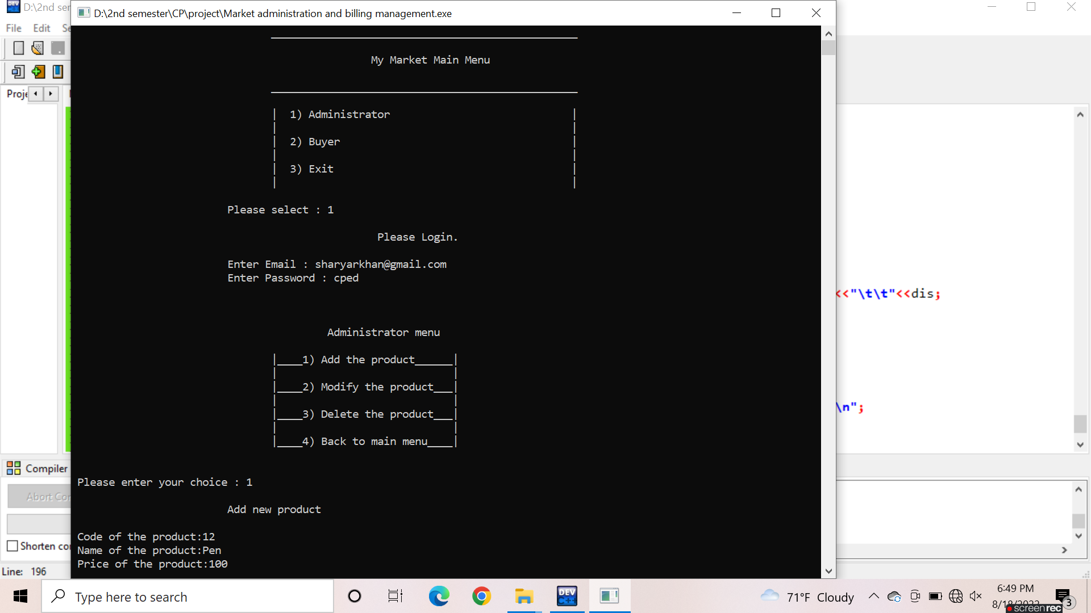

**Adding New Products:**

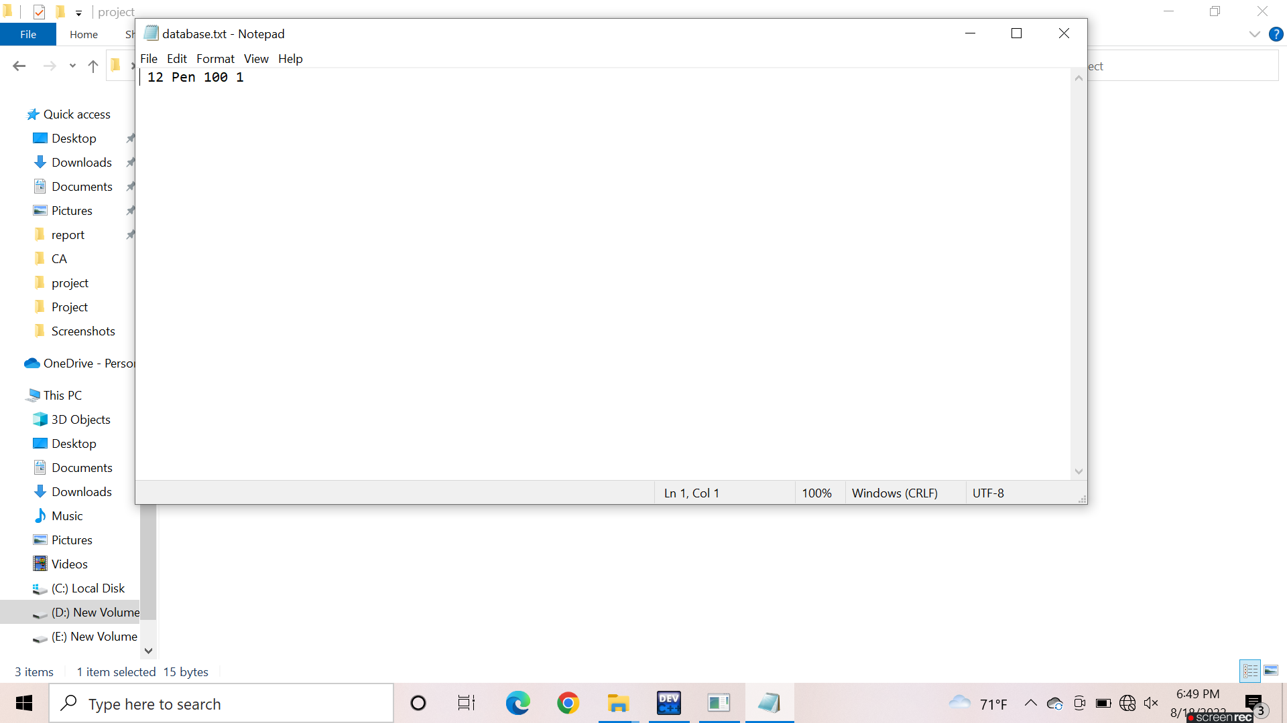The admins have to enter the code of the product, name, price and discount on the product. All the things will save in the txt file.

**Modifying the product:**

If the admins want to modify any product, they can do it easily. They just have to enter the code of previous product whom the want to modify and then can make changes in it**.**

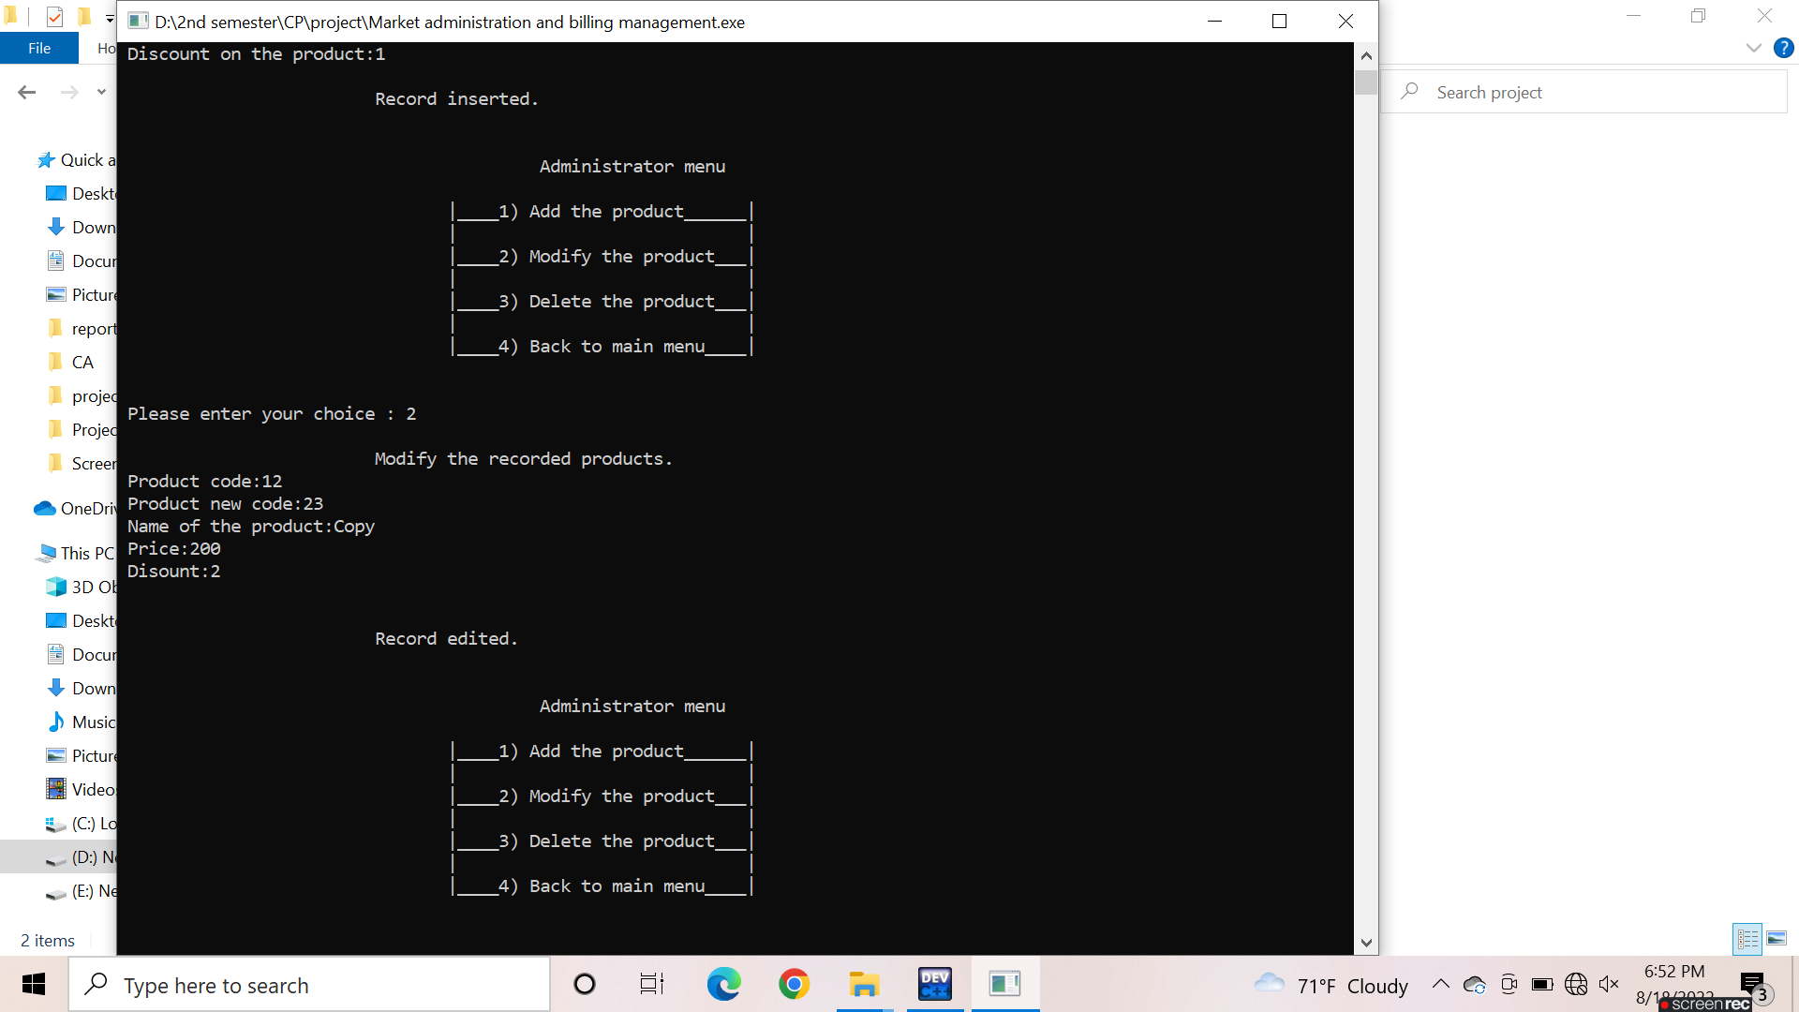

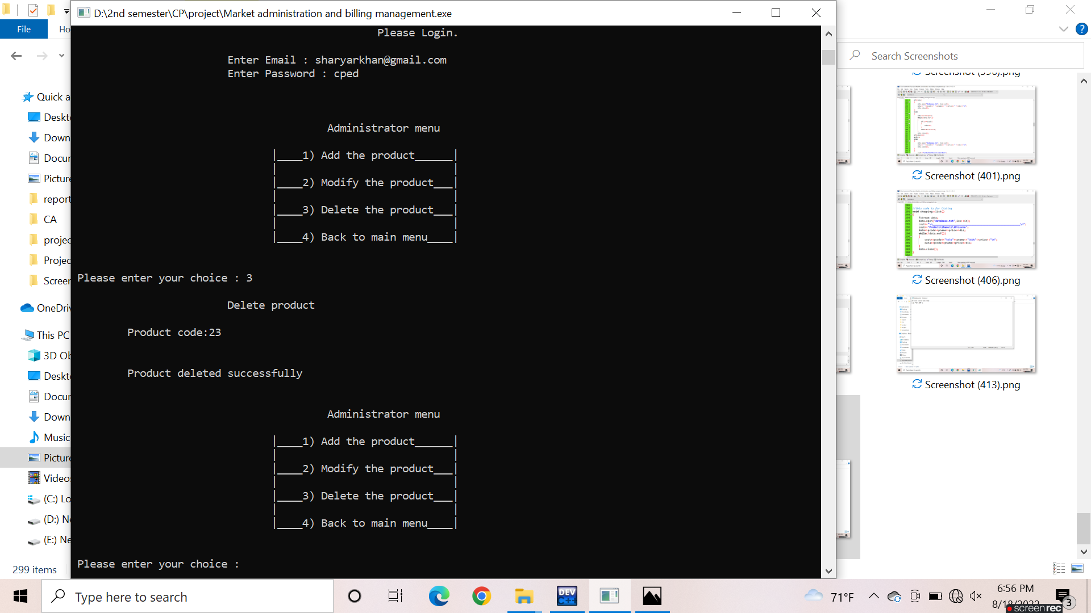**Deleting the product:** If the admins want to delete any product, they can do it easily. They just have to enter the code of product whom they want to delete and then confirm it.

**Buyer:**

The 2nd option is for the buyer. When the user will select the 2nd option, the available products will be visible to him. He just has to enter the code of product and quantity of products. After that the receipt will be shown to him with total bill through the discount.

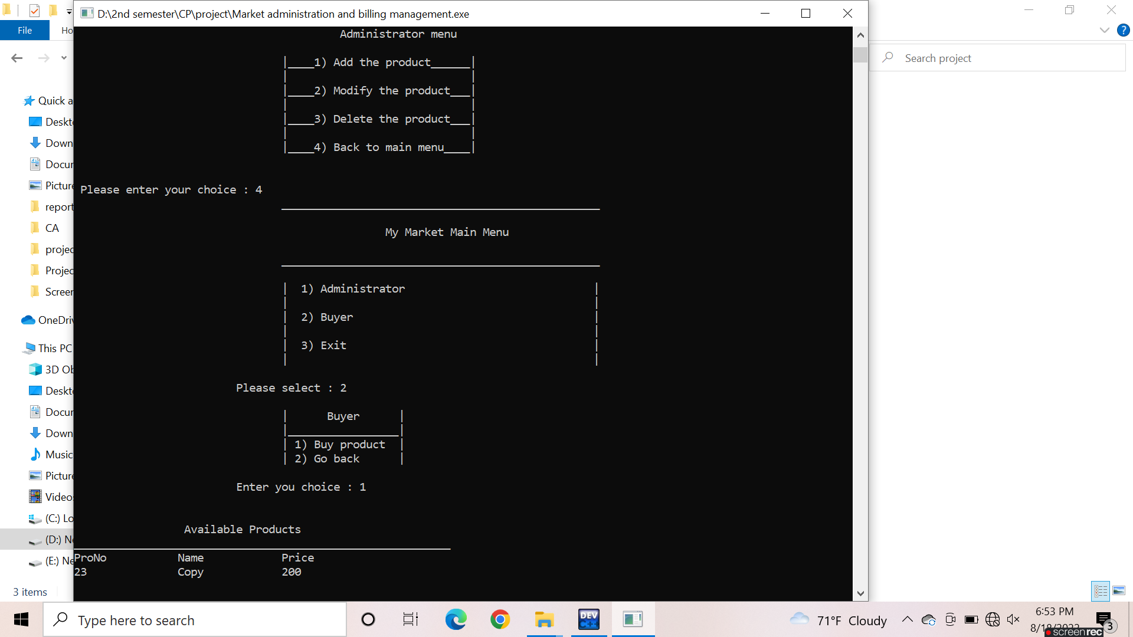

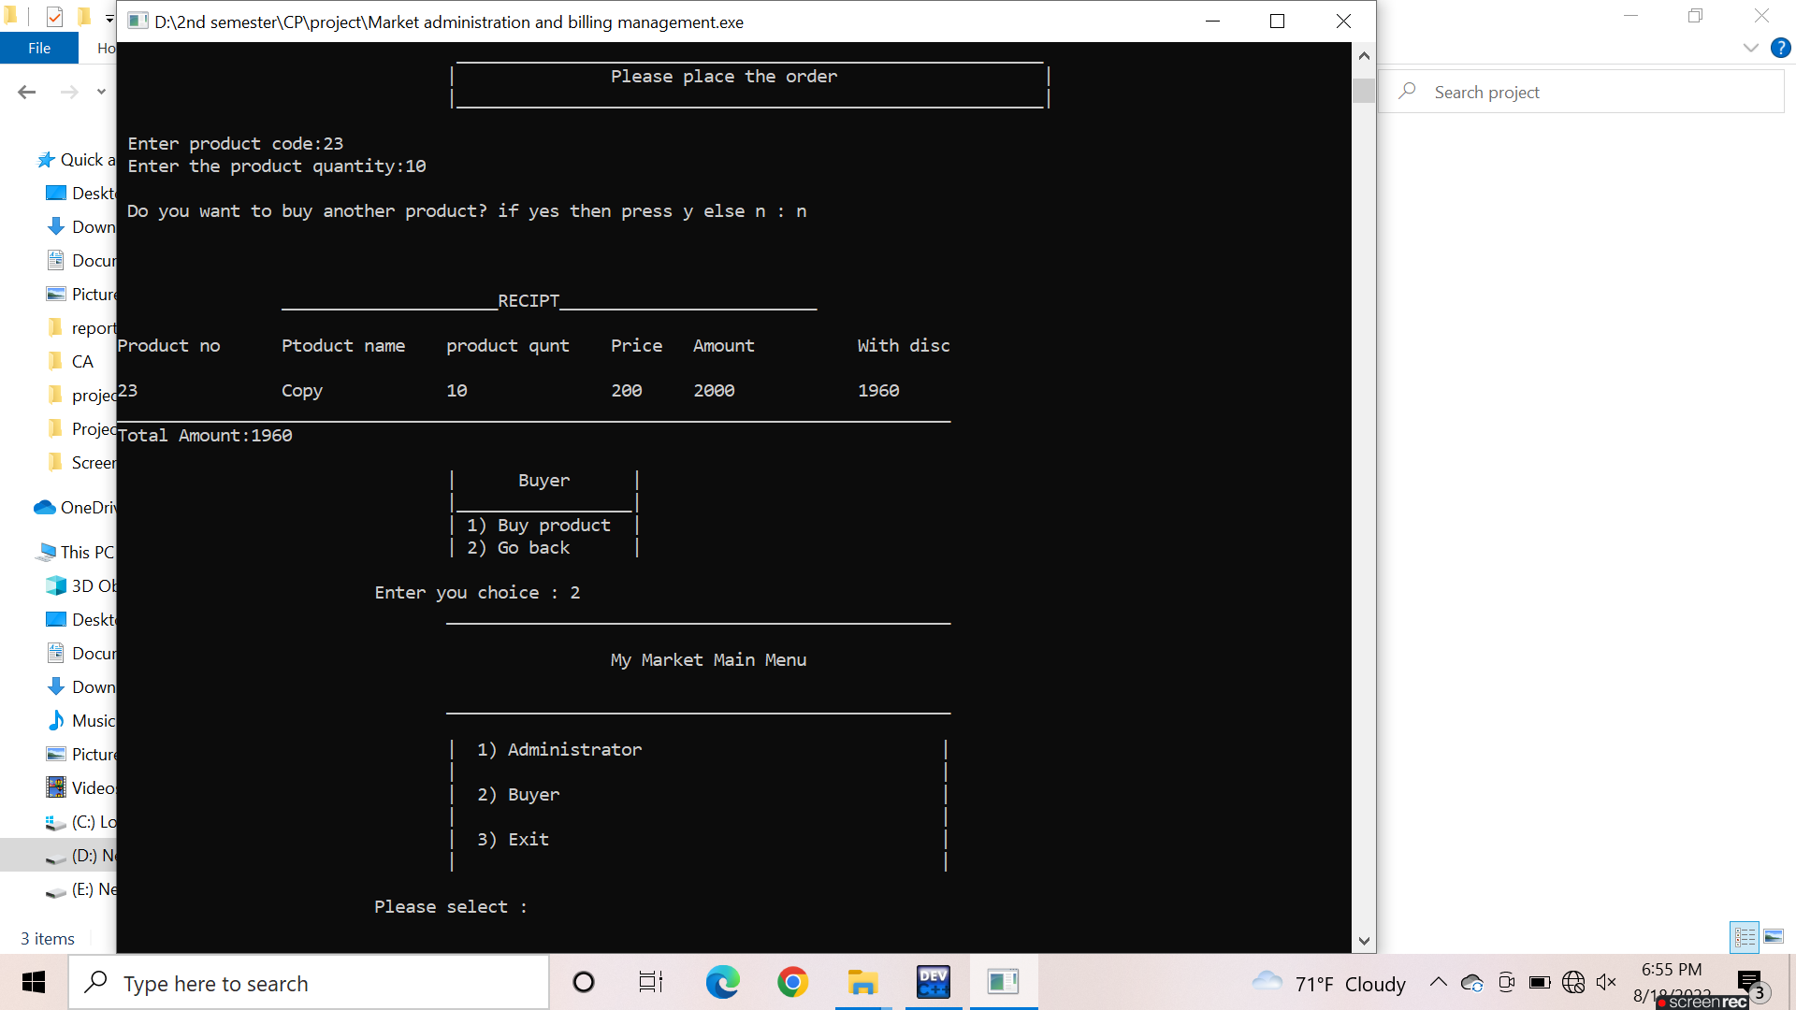

**………..The End………..**